How to Login SQL*Plus using

- Download Free Software Putty From Website
http://www.chiark.greenend.org.uk/~sgtatham/putty/download.html

- Enter either the IP addresses given below or npu9.npu.edu in the Host Name field and click open button

192.168.0.39(On campus)
216.133.192.39 (off campus)
Or npu9.npu.edu

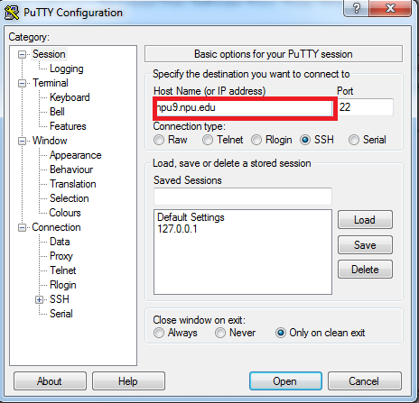
- After you connect to NPU Server,
Use your windows Username and password as you login NPU's computer
(Not oracle username cs547_xxxx)
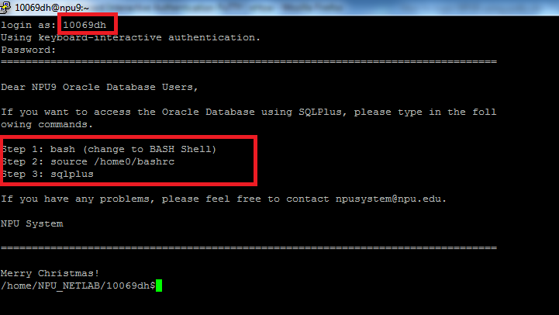

- Notice the above 3 steps . execute these commands in the given order at the unix/linux prompt
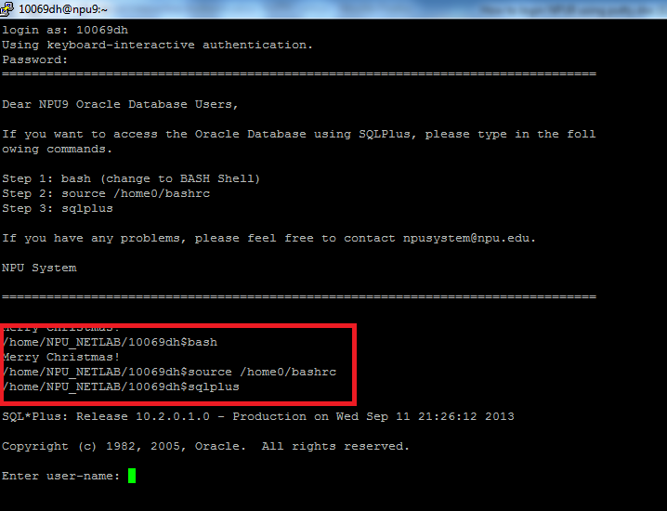
- Now, you are connected to Oracle SQL*Plus where in you need to enter your oracle user-name and password
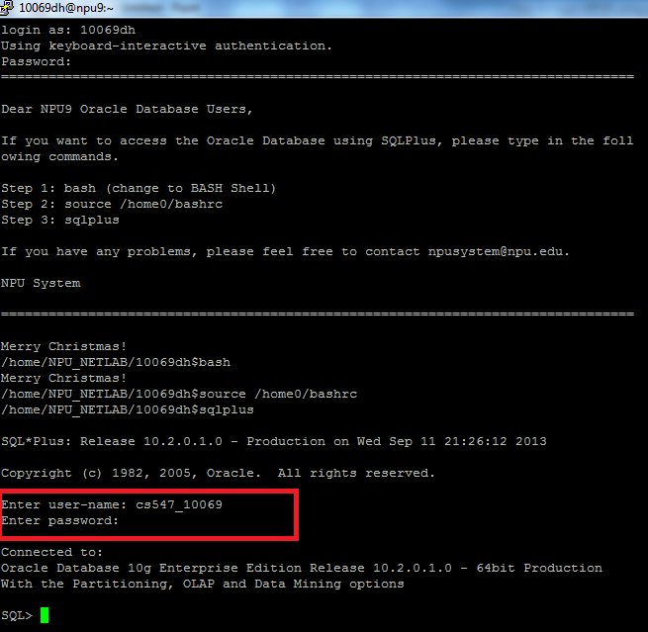
- You can see the SQL prompt available where you can execute your oracle plsql scripts or any other select statements
